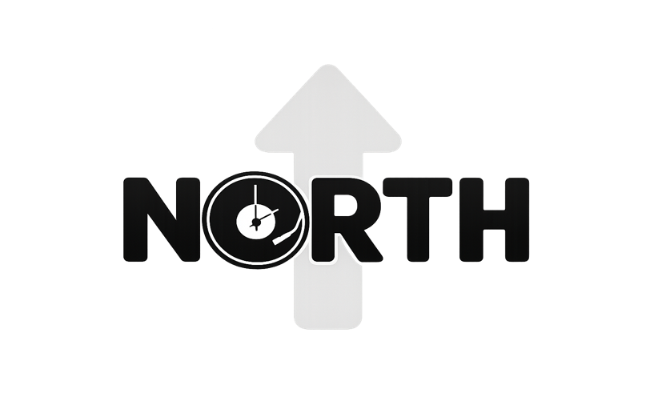

PLEASE SIGN AND RETURN TO
info@mitdjnorth.com

Customer Information:

Name Of Contact:
Email:
Phone:
Address:

Event Information:

Event Type:

Date:

Location:

Number Of Guests:

Start and End Times:

Event Cost:

Select Your DJ:
(Leave Blank If No Specific DJ Is Requested)

DJ Name:
$100.00
Request Charge:

Add On Features:

Up-Lighting Cost:

Glow Wand Cost:

Silent Disco Rental: 50 count 100 count

Channels X $75.00 per channel =

Terms and Conditions
- A $200.00 non-refundable security deposit is required when booking your event. This deposit is deducted from your total event cost and will show in your invoice statement. In consideration of the payment by the Purchaser as well as the various promises and the agreements set forth below, the Parties agree and intend to be legally bound as follows:
- Moments In Time Disc Jockeys North, LLC shall provide your hours of service as placed in the contract at the location given on the contract.
- Moments In Time Disc Jockeys North, LLC shall be provided and accepted on the following date and time of the engagement as given on the contract.
- Moments In Time Disc Jockeys North, LLC shall, at all times, have unmitigated control of its DJ Services.
- In the event that additional hours of DJ Services are requested after the finish time this agreement is executed, and Moments In Time Disc Jockeys North, LLC accepts said request, additional DJ Services will be charged at the rate of $150.00 per hour, payable the day of the engagement. The parties understand and agree that it may not always be possible to provide additional performance time; Moments In Time Disc Jockeys North, LLC is under no obligation to accept an offer to purchase additional hours of DJ Services.

Additional Terms and Conditions
The agreement of the DJ to perform is subject to proven detention by accidents, transportation issues, riots, strikes, epidemics, pandemics, any random acts of God, or any other legitimate conditions beyond their control. If such circumstances arise, all reasonable efforts will be made by Moments In Time Disc Jockeys North, LLC to make it to the event or find replacement entertainment at the agreed upon fees. Should Moments In Time Disc Jockeys North, LLC be unable to procure a replacement, Purchaser shall receive a full refund.
It is understood that if this is a "Rain or Shine" event; Moments In Time Disc Jockeys North, LLC‘s compensation is in no way affected by inclement weather. For outdoor performances, Purchaser shall provide overhead shelter for setup area. The DJ reserves the right, in good faith, to stop or cancel the performance should the weather pose a potential danger to him, the equipment, or audience. Every effort will be made to continue the performance. However, safety is paramount in all decisions. The DJ's compensation will not be affected by such cancellation.
No DJ Services, or any portion of the performance at the engagement, shall be recorded, reproduced, or transmitted from the place of performance, in any manner, or any means whatsoever, in the absence of a specific written agreement with Moments In Time Disc Jockeys North, LLC relating to and permitting such recording, reproduction, or transmission. Pictures and videotape of the event are permitted for the private use of the contracting party only.
Purchaser(s) agree that Moments In Time Disc Jockeys North, LLC’s liability shall not be liable in any amount of damage which exceeds the performance fees recited above. Further, the Purchaser(s) agree that Moments In Time Disc Jockeys North, LLC shall not be liable for indirect or consequential damages arising from any breach of contract.
It is understood that if Moments In Time Disc Jockeys North, LLC subcontracts services for your event and any liability issues or breach of this contract occurs, the subcontractor is the responsible party. Moments In Time Disc Jockeys, LLC is not responsible for the subcontracted services provided, equipment, or performance of services. Any and all issues, court costs, attorney fees and legal damages are the responsibility of the subcontractor, not Moments In Time Disc Jockeys North, LLC.
The Purchaser(s) and DJ servicer agree that this contract is not subject to cancellation unless both parties have agreed to such cancellation in writing. In the event of cancellation by the Purchaser(s) within 60 days of the their event date, the Purchaser(s) shall pay the amount of
$300.00 as liquidated damages, plus a reasonable attorney's fee. If the Purchaser(s) cancel the event within 30 days of the set event date, the Purchaser(s) shall pay the DJ servicer the total agreed amount set forth on the contract as liquidated damages, lose their security deposit, plus a reasonable attorney’s fee.
It is further agreed that the Purchaser shall be liable for any and all injury or damage to the DJ, or property of the DJ, while on the premises of said engagement, if damage is caused by Purchaser or guest, members of his organization, engagement invitees, employees, or any other party in attendance, whether invited or not.
In the event of circumstances deemed to present a threat or implied threat of injury or harm Moments In Time Disc Jockeys North, LLC staff or any equipment in Moments In Time Disc Jockeys North, LLC possession, Moments In Time Disc Jockeys North, LLC reserves the right to cease performance. If the Purchaser is able to resolve the threatening situation in a reasonable amount of time (maximum of 15 minutes, Moments In Time Disc Jockeys North, LLC shall resume performance in accordance with the original terms of this agreement. Purchaser shall be responsible for payment in full, regardless of whether the situation is resolved or whether Moments In Time Disc Jockeys North, LLC resumes performance. In order to prevent equipment damage or liability arising from accidental injury to any individual attending this performance, Moments In Time Disc Jockeys North, LLC reserves the right to deny any guest access to the sound system, music recordings, or other equipment.
Purchaser shall provide Moments In Time Disc Jockeys North, LLC with safe and appropriate working conditions. This includes a 10-foot by 10-foot area for setup, space for setting up the DJ equipment and extra necessities. Moments In Time Disc Jockeys North, LLC requires a minimum of one 15-20-amp circuit outlet from a reliable power source within 25 feet (along the wall) of the set-up area. This circuit must be free of all other connected loads. Any delay in the performance or damage to the DJ equipment due to improper power is the responsibility of the purchaser. Two circuits are preferred, where possible.
In the event of non-payment, Moments In Time Disc Jockeys North, LLC retains the right to attempt collection through the courts. Purchaser agrees to be held responsible for all court costs, legal fees, and collection costs incurred by Moments In Time Disc Jockeys North, LLC. Purchaser shall be charged $30 for each returned check. It is agreed that Michigan law shall control all aspects of this Agreement.

Purchasers agree to make all necessary arrangements to provide the DJ with access to the event venue not less than 1 hour before the engagement and 45 minutes after the engagement for setup and takedown. Moments In Time Disc Jockeys North, LLC also requests ramp or elevator access between the parking/service entrance and the setup area.
By executing this contract as Purchaser, the person executing said contract, either individually, or as an agent or representative, represents and warrants that he or she is eighteen (18 years of age, and further, if executing said contract as agent or representative, that he or she has the authority to enter into this agreement and should he or she not have such authority, he or she personally accepts and assumes full responsibility and liability under the terms of this contract.

This document, together with any attachments initialed by the parties, shall constitute THE ENTIRE AGREEMENT of the parties. If any part of this contract is illegal or unenforceable, the remaining provisions of this contract will remain valid and enforceable as to both parties.

Again, this document contains the ENTIRE AGREEMENT BETWEEN THE PARTIES and no statement, promises, or inducements made by any party hereto, or agent or representative or either party hereto, which are not contained in this written contract, shall be valid or binding. This contract shall not be enlarged, modified, or altered except in writing by both parties and endorsed hereon
The laws of the State of Michigan shall govern this agreement. In the event that legal proceedings are initiated by either party, it is agreed that proper venue shall be in Grand Traverse County.
Purchaser(s) agree to indemnify, defend, assume liability for and hold Moments In Time Disc Jockeys North, LLC’s harmless from any claims, damages, losses and expenses by or to any person, regardless of the basis, which pertains directly or indirectly to Moments In Time Disc Jockeys North, LLC performance. In the event that a civil action arises in an effort to enforce any provision of this agreement, the losing party shall pay the attorney's fee and court costs of the prevailing party.
Purchaser(s) may not transfer or assign this contract to another party without the prior written consent of Moments In Time Disc Jockeys North, LLC.
THE PARTIES acknowledge that they have read the above Agreement in its entirety, understand all of its terms and conditions, have had an opportunity to review the same with legal counsel, and agree to abide by the terms of this agreement of his/her own free will and consent

BY TYPING YOU ARE SIGNING

Agreed: Date:

Client Signature

Agreed: Date

Moments In Time Disc Jockeys North Signature

